USER MANUAL
Accounting Management System (AMS)

Prepared by Rupnahar (Rupa)
Reviewed & Approved by Md. Afzalur Rashid
Date: 07 July 2020
Version:6.00


Company Name: SoftByte IT Solution
Address:
24/2 Pollobi (2nd Floor), Mirpur, Dhaka

1.1 Logging In
From your computer’s start-up menu click to initiate a web browser preferably (Firefox , Safari , or Chrome ) as this application is meant to run on web.

When the browser (Firefox , Safari , or Chrome ) opens
type in Aqua-Tex URL (https://aquatex.softbyte.co/authentication) in the address bar of the browser & punch enter.
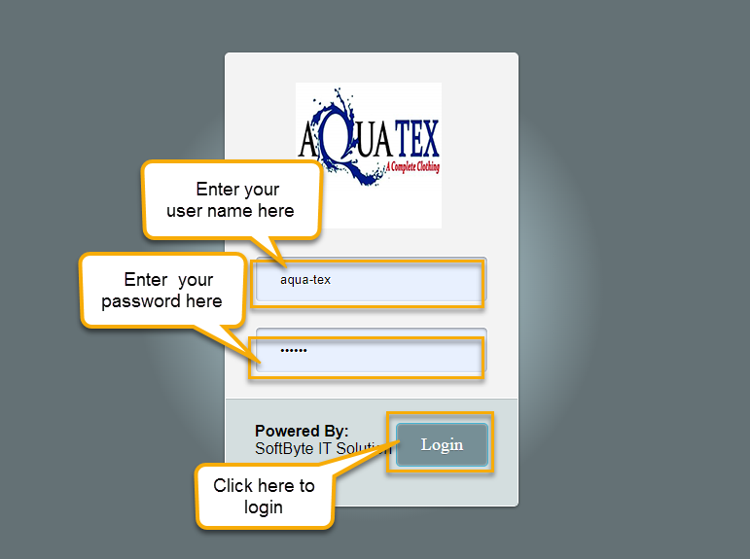
A login screen will appear as show in the figure below.

Fig: Login Page

1.1.0. To Login:
- Input User Name
- Input Password
- Press Log In button

2.1 Aqua-tex Modules
In terms of operations Aqua-tex application can be classified into following:
- Dashboard.
- User Management.
- Accounts Settings.
- Voucher Create.
- Posting Voucher.
- Accounts report.

2.2 Accounts Workflow
The diagram below represents the flow of work through the Accounts workflow system

Upload/Create chart of accounts

Voucher create

Voucher posting

Report

3.Using Aqua-Tex Administrator:
After successful login to the system as an administrator this is the first view of the dashboard that you will be presented with.
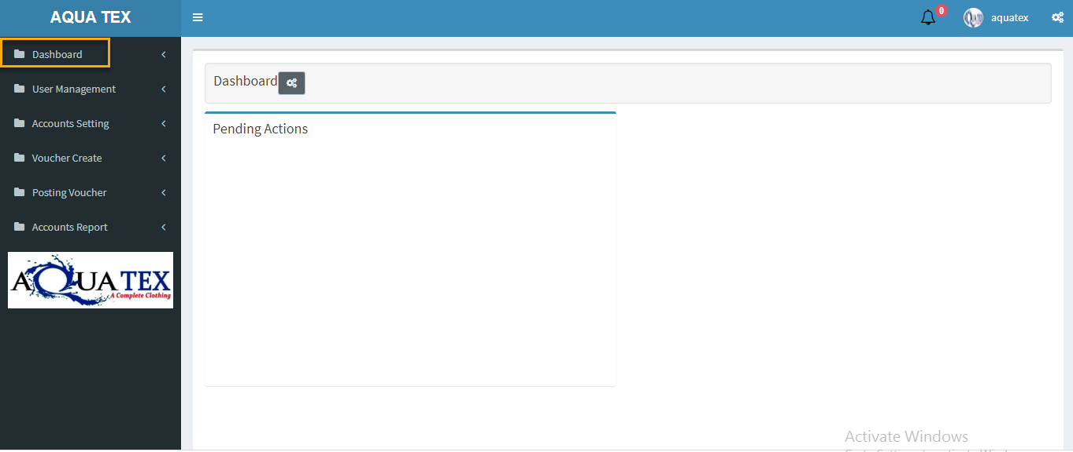

3.0 Administration
Administration is home to all the settings & configurations of the system. Primary tasks performed by an administrator are as follows:
- Create & configure ‘accounts setting (Bank, Bank account, Bank Branch, check book, check leaf, customer, supplier, employee, cost center list)
- Create User accounts for new user
- Create User Groups (when required)
- Configure/Re-configure ACL (Access Control) - Authorities for Users or User Groups (where necessary)
- Configure Chart of accounts.

4.1 ACL
The term ACL stands for Access Control List. This feature will help you define permission to access the software feature. First you need to define the permission. ACL is comprised of - Module, Module Feature, and Authority.

4.2 Authority
We want to assign specific tasks to specific individuals and set permission so that he will get access to only those areas and features of the software that we allowed him. We can do that by creating an Authority and configuring the level of module & feature permissions.
When you click on Authority under ACL the following page should appear.
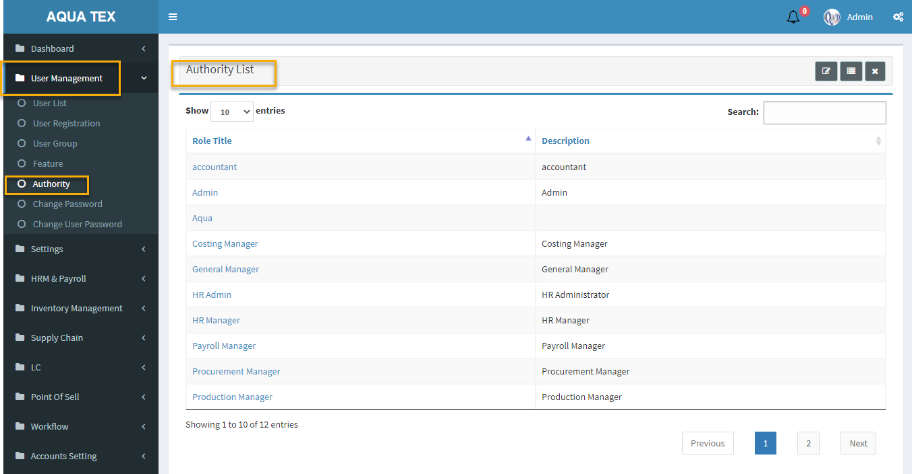

4.5. Create Authority:
Click button located on top right corner of page. Create authority form should load on screen.
- Type in a name in ‘Authority Name’ field.
- Type authority description.
- Then set the ‘Feature Permission’

- When permission configured click create To reset form click

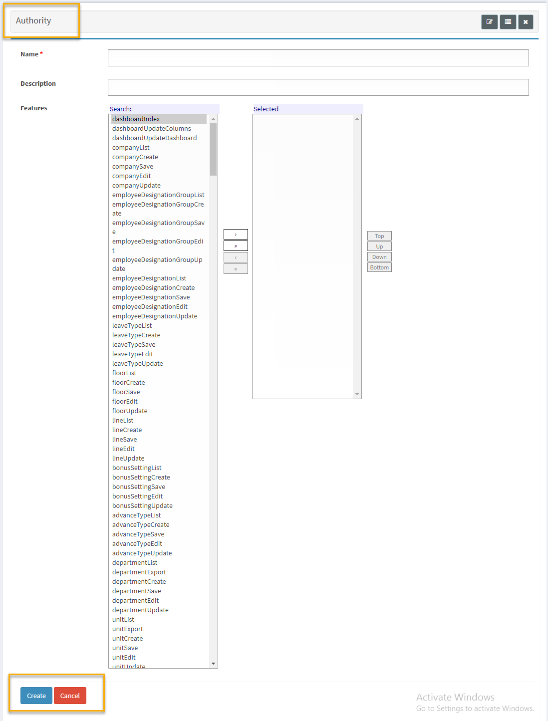

4.4.1. How to Configure Permission:
Let’s take the example of a Voucher create We want to configure permission so that he can perform the following tasks:

Tasks:
- Login & View his Dashboard
- Create cash receive voucher.
- Create cash payment voucher.
- Create bank receive voucher.
- Create bank payment voucher.
- Post Voucher.

4.4.2. Steps to Set Permission:
- Create an Authority by clicking
- Name the authority ‘Aqua-tex’
- Scroll down to ‘Module Permission’, & high-light ‘voucher’ by holding down CTRL key in keyboard and clicking on them.
- Now click arrow 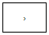button to select & transfer the high-lighted modules from the left box to the box on the right-hand side of the screen as shown in figure below.

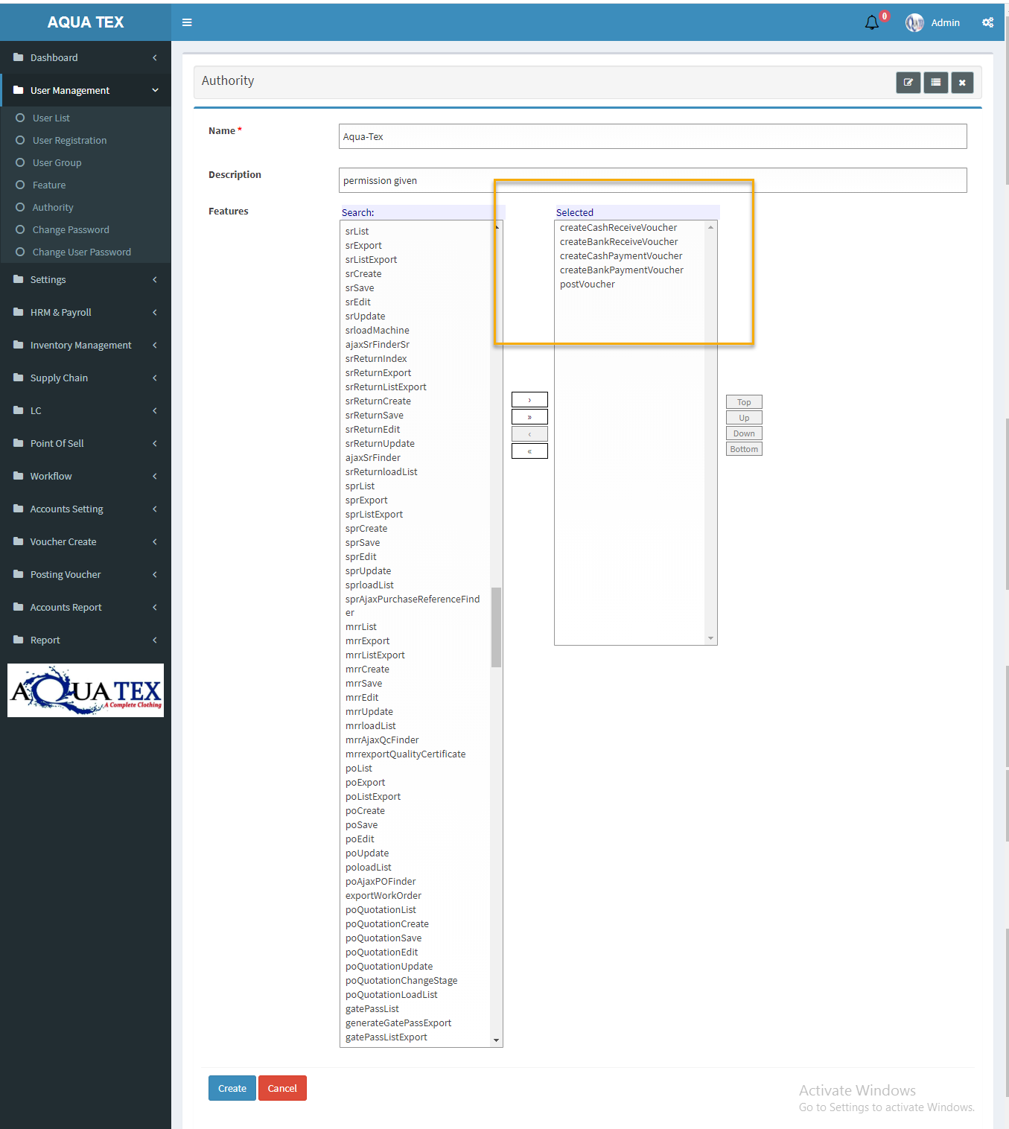

5.Module permission is now set.

5 User list:
A user is an authorized person who has access to the system. Every person who wants to operate this software must need a user account and password. We must first create a user.
Click on User under Administration to load User list page on screen.

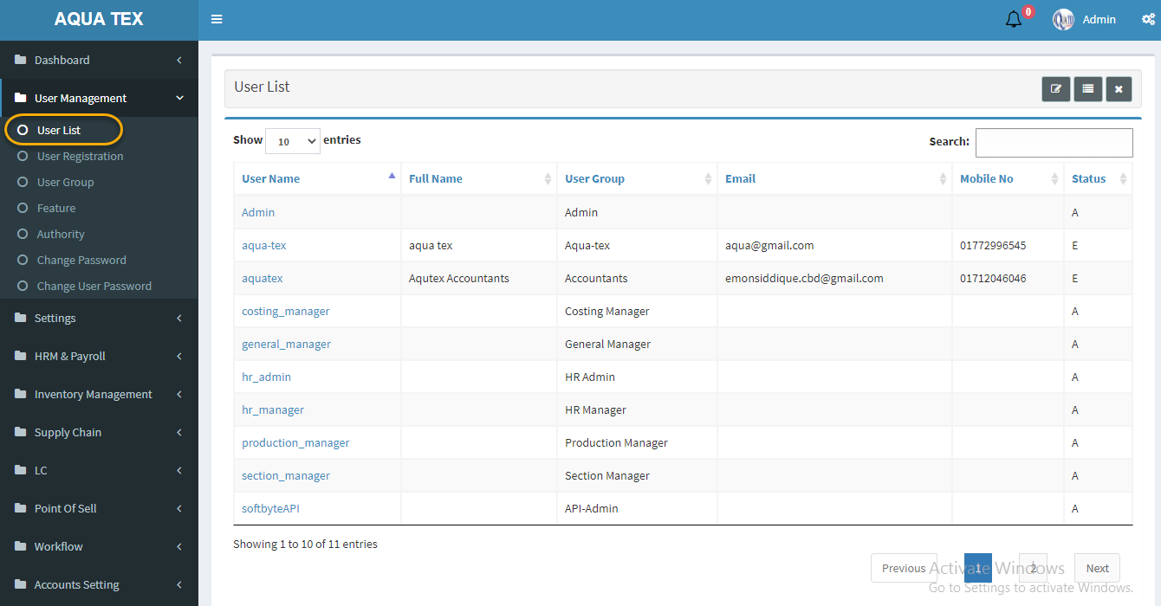

4.5.0. Create User:
Click button from top right of page. A new popup window will open as shown below.
- Write user Id.
- Give a suitable user name (preferably that which reflects the function of the User Group selected)
- Type & re-type a password (Note: Ensure that you choose a password that is easy for you to remember, but difficult for others to guess.)
- Select User Group.
- Give a valid email address in ‘Email’ field
- Enter Cell no. (if any)
- Select the ‘Authority’ created for this User Group

- Click

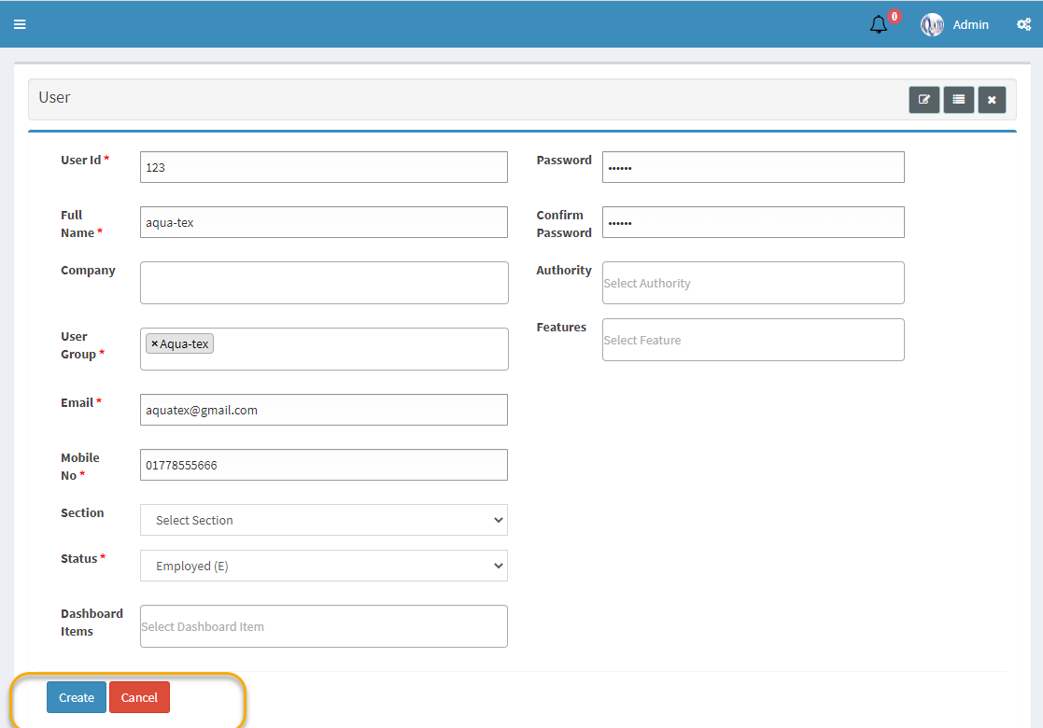

4.5.1. Edit User:
To edit existing user info
- Click the option Edit A new popup window will open as shown below.
- The System will populate selected information to the respective field.
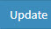
- Make necessary changes. Press Update button.
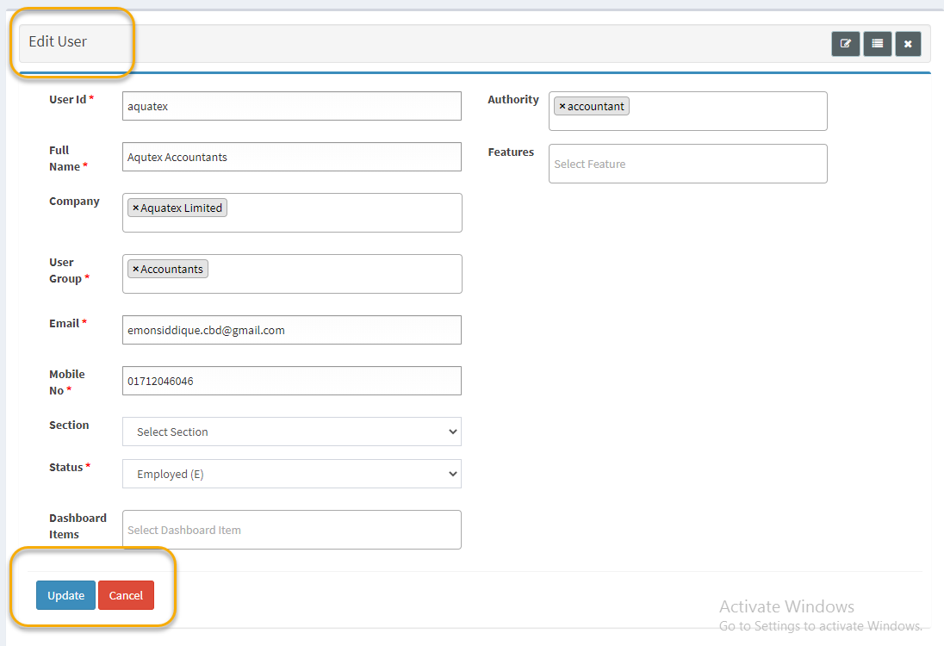
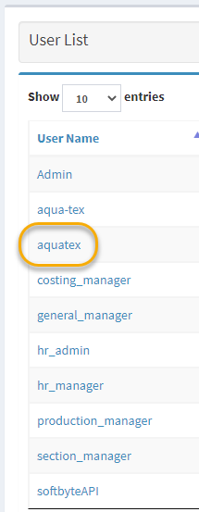

4.6 User Group
User groups are created to group a bunch of users with common attributes together. Say a Mill Group to identify Mill users who will enjoy a common set of permissions to perform some specific tasks.
User group is also under Administration menu, shown below.
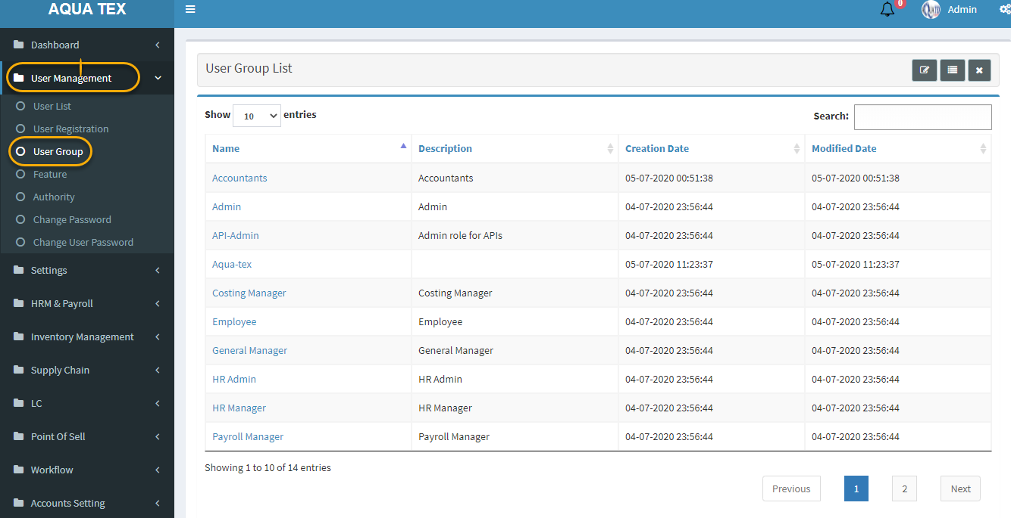

.6.0. Create User Group:
- Click button on top right of the page. A new window will open as shown below.
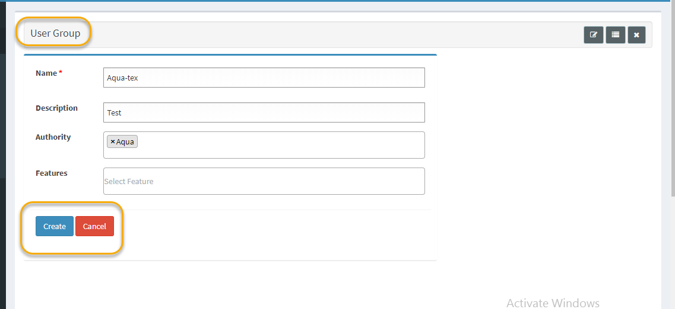

  - When form is filled click create button to save data.
  - If admin wants to skip create user-group, then press cancel button.

4.6.1. Edit User Group:
To edit existing user-group
- Click the option Edit. as shown below.
- Edit window should open populated with previously set data.
- Make necessary changes. Press Update button.
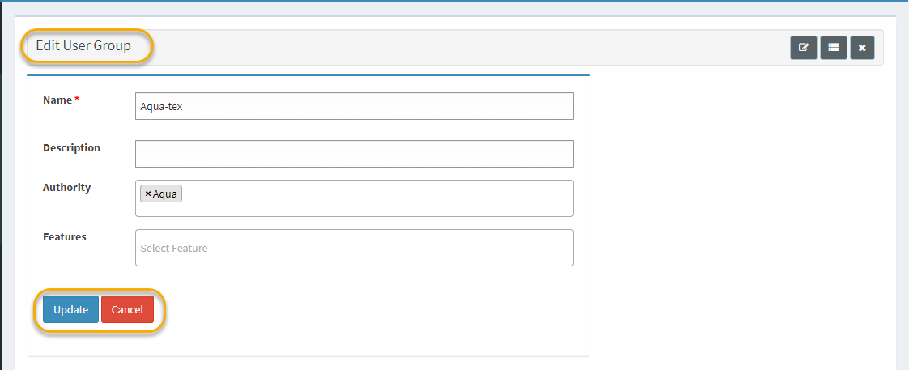

5.1 To Change Password:
Log into Aqua-tex and click the Change Password link displayed at top right corner of the panel.

Change Password screen will appear
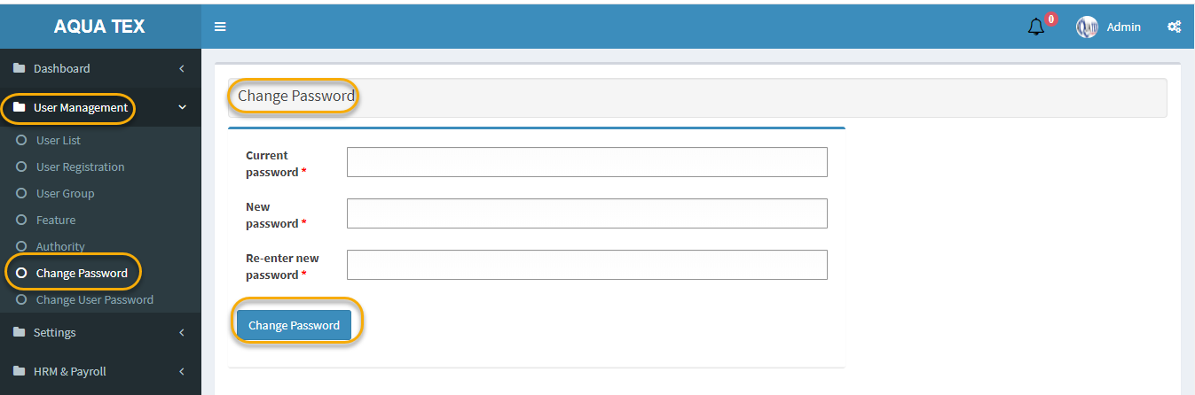

Fig: Change Password

In the Change Password dialog box, enter
Current Password: your current password in the Old Password box.
New Password: a new password in the New Password box
Re-enter the new password: re-enter the new password in the Re -Type Password Box.
Click Change Password button to change the password.

5.1 To Change Password:
Log into Aqua-tex and click the Change User Password link displayed at top right corner of the panel.

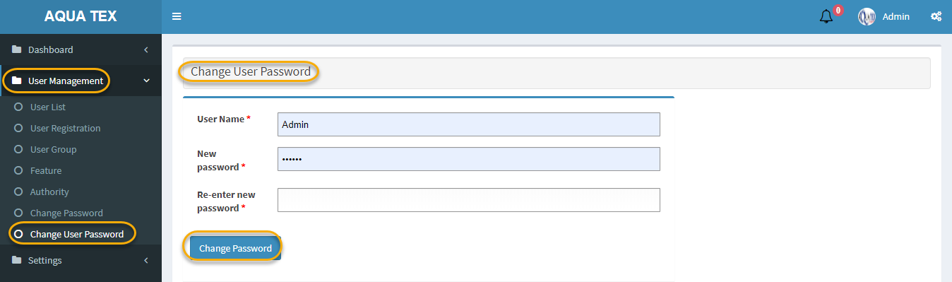
Change User Password screen will appear

In the Change Password dialog box, enter
User Name: your current user name in the User Name box.
New Password: a new password in the New Password box.
Re-enter the new password: re-enter the new password in the Re -Type Password Box.
Click Change Password button to change the password.

6.Bank account:
It is a sub-menu under Accounts setting. The Bank account menu lets new bank information to be added to Aqua-tex system, and configure its settings before voucher creating.
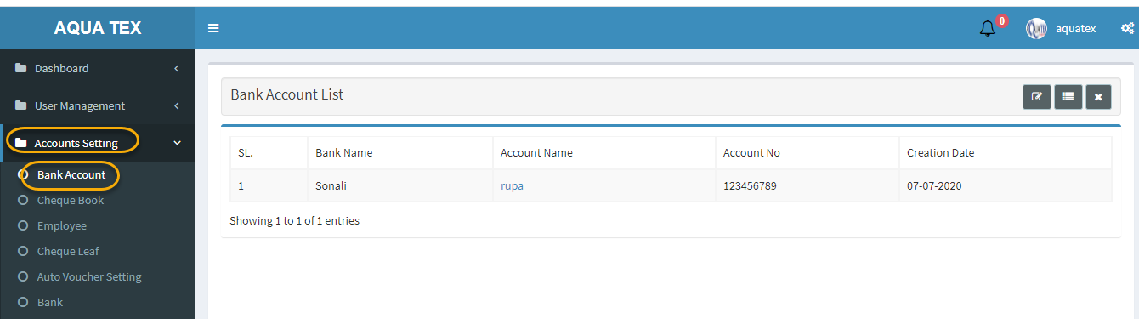

6.1 Create Bank:
- Click from top right corner of page. A form window as shown below.
- After filling the form click button to create data to server.
- To skip press button.
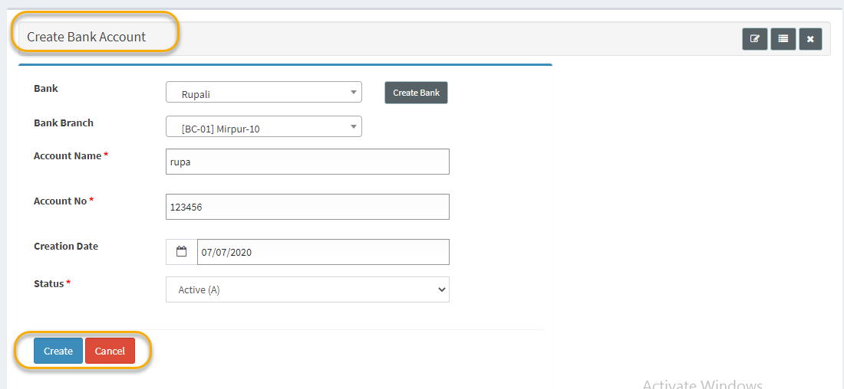

6.2. Bank Edit:
If you need to edit any Bank related information just click Bank list account name column.
- An edit form window populated with data should pop-open.
- Make necessary changes.
- Press update button.
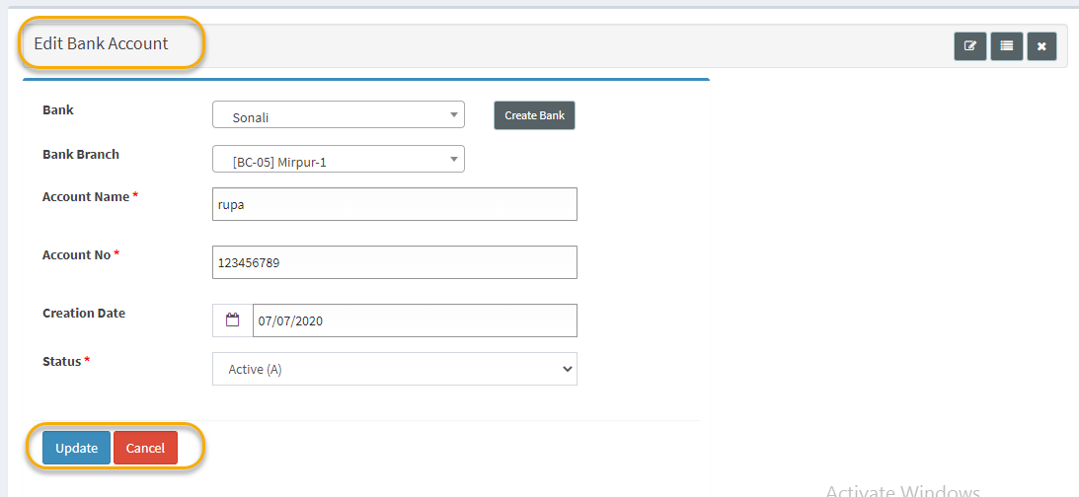

7.Bank account:
It is a sub-menu under Accounts setting. The Bank account menu lets new bank information to be added to Aqua-tex system, and configure its settings before voucher creating.

